Functional requirements

|  |  |  |
| --- | --- | --- |
| Basic function | Function name | Function description |
| 1 | Home page landing | Create a home page that is the main page for users landing when they access from url. Contain overview about the website |
| 2 | Shopping page | Direct users to this page whenever they want to see all products |
| 3 | About us page | Page that contain information like history, address, contact number of the shop |
| 4 | Register & Login authentication | Create a login page that allow user to login their accounts or register if they don’t have one. The login will require password for ensuring user’s identities. |
| 5 | Product review page | Direct users to this page when they click on 1 product to see all description of this product and allow user to add to cart or buy now (place order). |
| 6 | Add to cart | Adding product to cart with 1 click |
| 7 | Shopping cart | This function allow user to see all products added before also contain product, name, price, quantity and also total number of money. Also have a place order button |
| 8 | Place order | This function allow user to place order if they already login and allow payment method. If user haven’t login they will be directed to login page above (function 4). |
| 9 | Order viewing | Allow user to see the orders that they placed and showing the status of order (not purchased, purchased, delivering, delivered, refunded, …) |
| 10 | Add/ remove orders | Users can add more (quantities) or remove exist orders. |

|  |  |  |
| --- | --- | --- |
| Advance function | Function name | Function description |
| 1 | Searching bar | Allow user to search the products from search bar. Return none if keyword is not match with any products |
| 2 | Set of filter | From shopping page user can filter the products category like top seller, price, combo, sale, etc. Return the products with suitable tags. |
| 3 | Consultant live system | Having chat bot that consult users the type of products they need and direct them to that product review page.  Answering users question automatically with appropriate answer. |
| 4 | Recommendation system | Recommend products for users base on the content of products and the users’ buying behaviours. |
| 5 | Shipping and payment integration | Integrate payment method like momo, zalo pay, paypal,… and shipping like grab, go. |
| 6 | Admin/customers roles | Having 2 types of account:  + Customers: buy now, add to cart, place order, remove their orders, modify their details information.  + Admin: allow owners to manage users, manage products, manage orders, etc.  Admin can see all users, products, orders have been placed and modify them. |
| 7 | Out of stock status | Allow admin to modifies product selling status |
| 8 | Price update | Allow admin to update many products at the same time |
| 9 | Manage order | Admin can view list of order and can change the status of orders, admin can confirm or deny orders, cancel orders. |
| 10 | Manage users | Admin can see list of users and things they bought (recommendation system also see this), admin can see users details: name, email, contact number. |

Non-functional requirement

|  |  |  |
| --- | --- | --- |
| No | Function name | Function description |
| 1 | Performance | - Page interaction should be less than 30seconds.  - Homepage must be fully loaded in 15seconds. |
| 2 | Security | - Require password encryption for users.  - Require verification when new registration appeared. |
| 3 | Resilience | - Website must be up 95% time, 24/24. |
| 4 | Modifiable | - Users can modify their information.  - Users can modify their cart/orders. |
| 5 | Friendly view | - Text will be 16px, header will be double depend on type of headers.  - All devices can see website clearly and well.  - Responsive for all devices. |
| 6 | Maintainability | - Products update frequently.  - Price of products update frequently. |

Class diagram

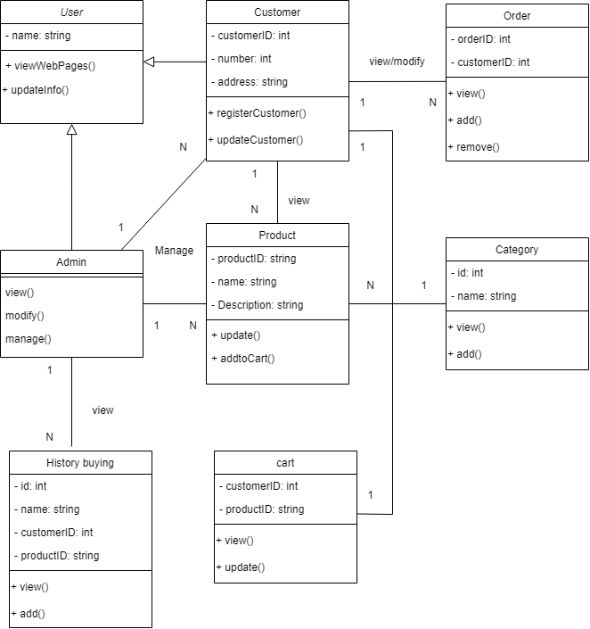

Chatbot and recommendation integration overview model:

